I/ READ AND MATCH:

|  |  |  |  |
| --- | --- | --- | --- |
| 1 |  | A | time /do / What /you / school / ? / go / to |
| 2 |  | B | Get / I / up |
| 3 |  | C | I / to / eight / school / go / at / o’clock./ |
| 4 |  | D | I / dinner /. have |
| 5 |  | E | I / go / school /. / to |
| 6 |  | F | go / home / I |
| 7 |  | G | time / What / is / ? / it |

|  |  |  |  |  |  |  |
| --- | --- | --- | --- | --- | --- | --- |
| 1. B | 2. | 3. | 4. | 5. | 6. | 7. |

II. 

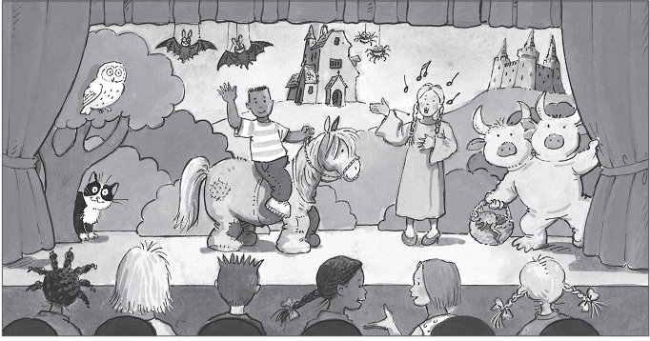  
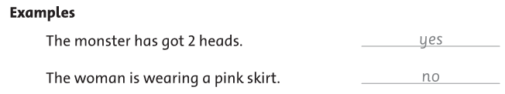

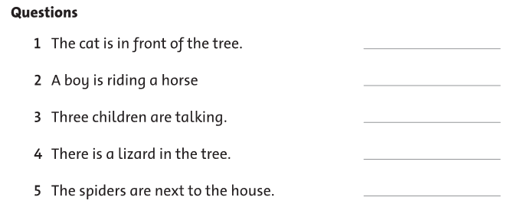

**III. Look at the picture. Write the words**

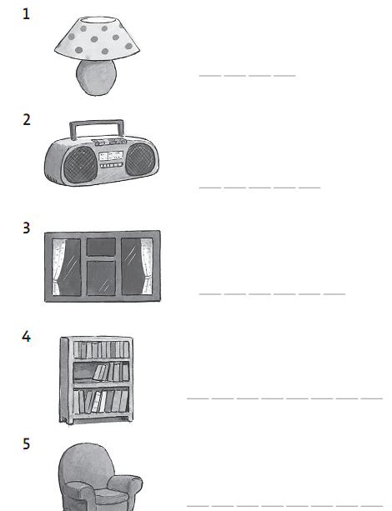

IV**. Read this. Choose a word from the box. Write the correct word next to numbers 1-5. There is one example.**

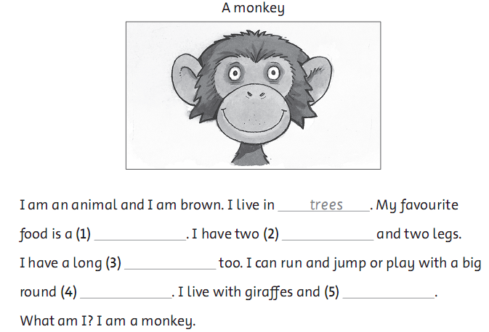

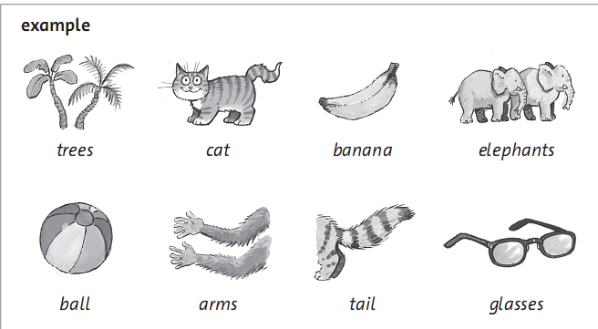

V. **Look at the pictures and read the questions. Write one-word answers. There are two examples.**

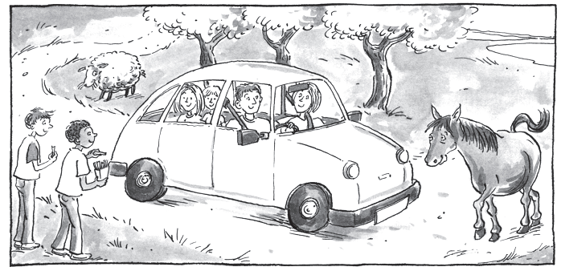

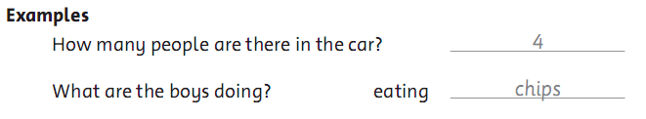

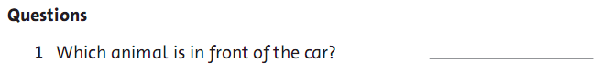

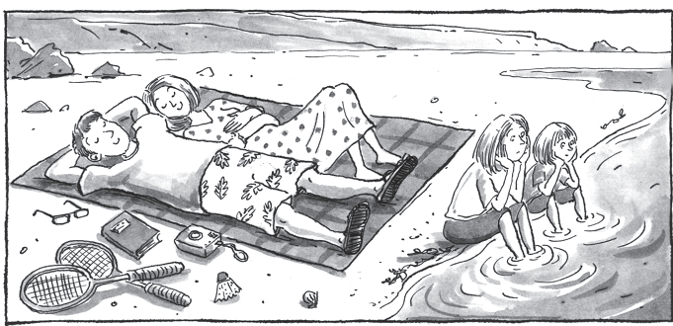

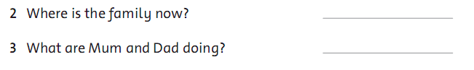

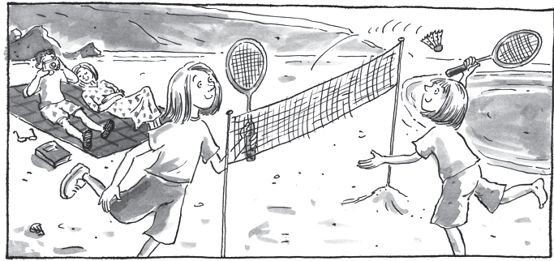

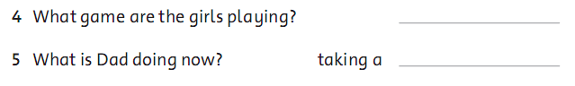

**VI. Look and read. Put a tick (🗸) or a cross (🗴) in the box. There are two examples.**

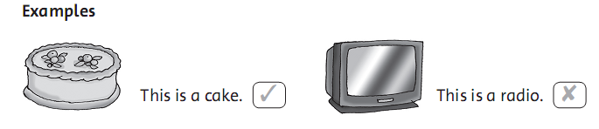

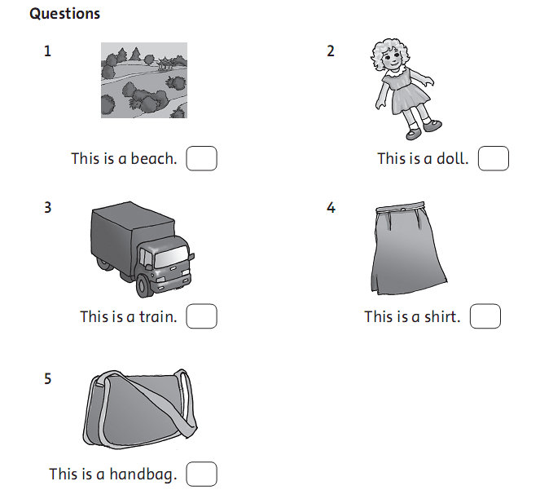

**VII. Look and read. Write Yes or no. There are two examples.**

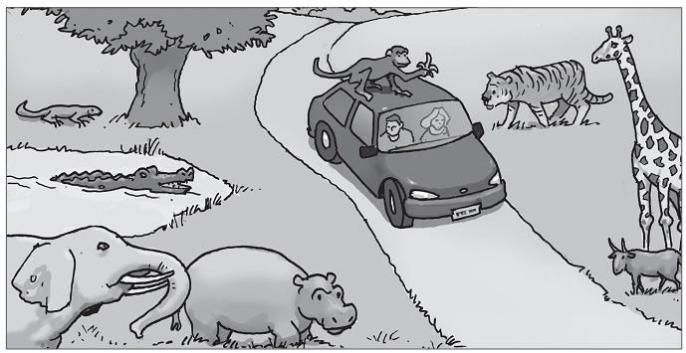

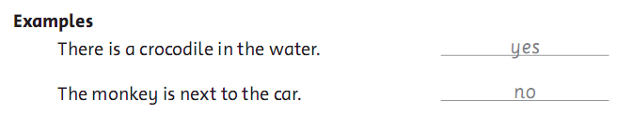

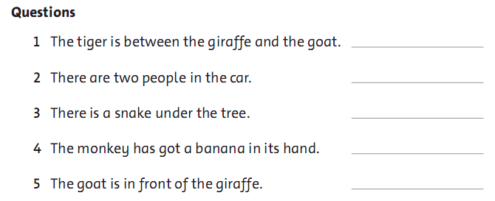

**VIII. Look at the pictures. Look at the letters. Write the words. There is one example.**

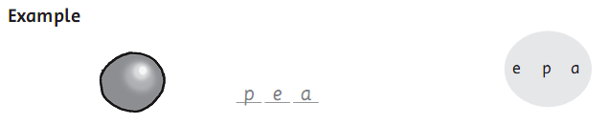

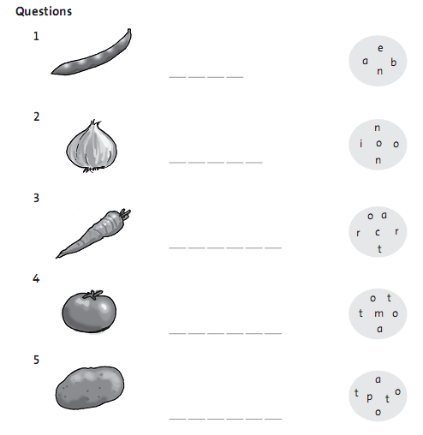

**IX. Read this. Choose a word from the box. Write the correct word next to numbers 1-5. There is one example.**

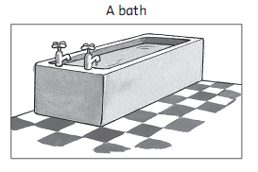

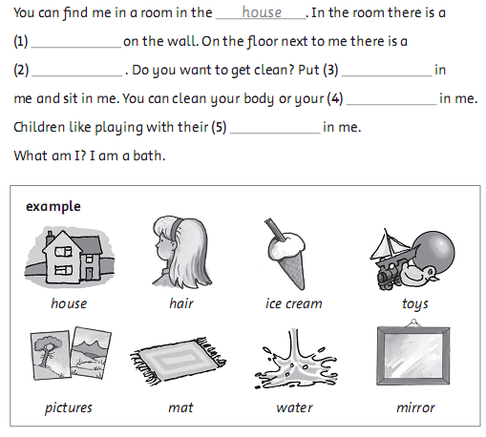

**X. Look at the picture. Circle A,B or C.**

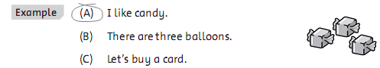

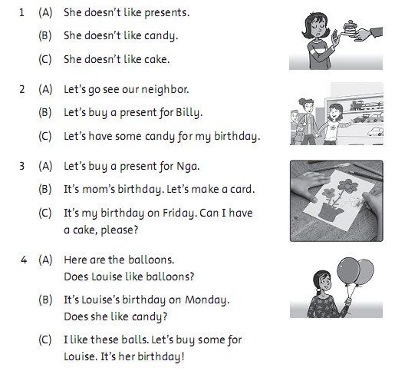

**XI. Read and guess. What is it? Circle A,B or C.**

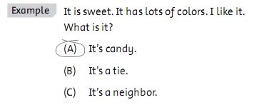

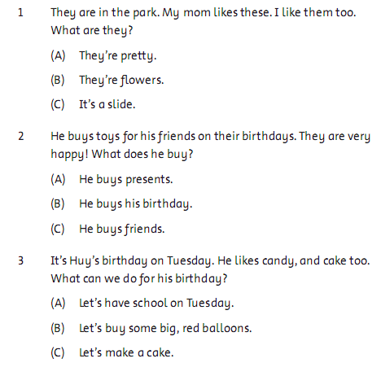

**XII. Read and answer the questions. Circle A, B or C.**

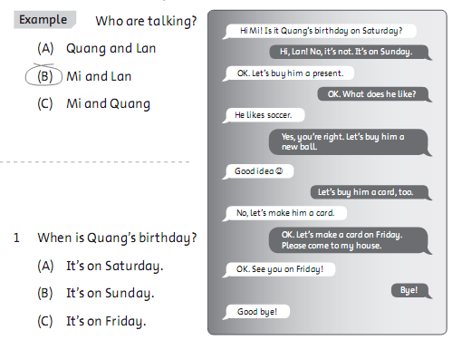

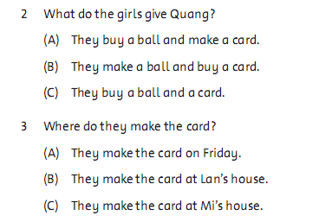

**XIII. Join. Write the words and draw.**

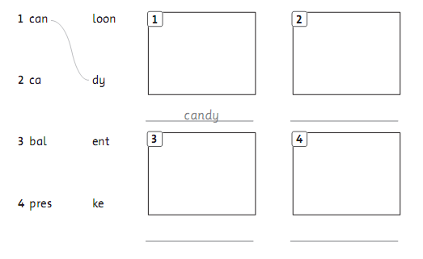

**XIV. Look and write.**

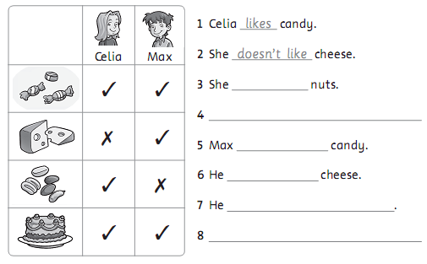

**15. Look and circle. BLUE = good ; RED = bad**

**Read and color.**

