**ÔN TẬP TỪ 23 đến 27/03/2020**

**1/ Read and draw the times**

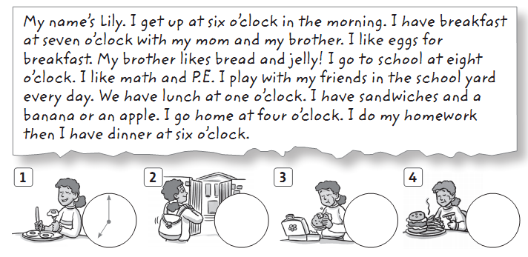

**2/ Read again and write *T* (true) or *F* (false)**

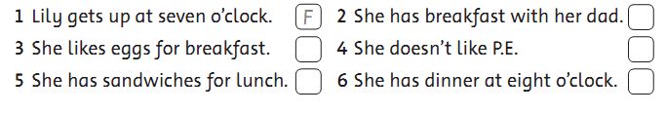

**3/ Look and complete the sentences.**

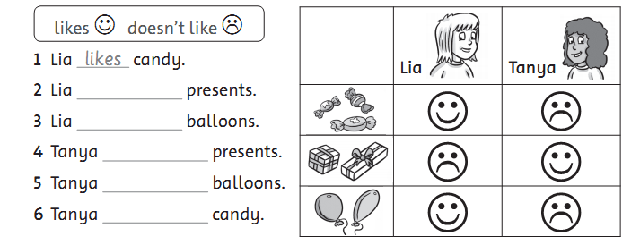

**4/ Look and answer.**

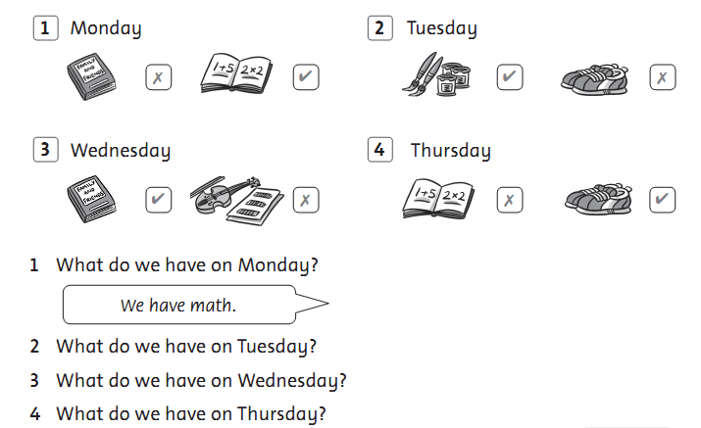

**5/ Look and read. Put a tick (🗸) or a cross (🗴) in the box. There are two Examples.**

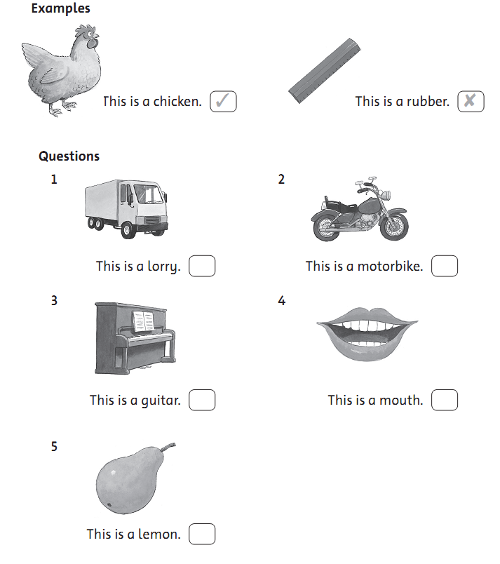

**6/ Look and read. Write *Yes* or *no*. There are two examples.**

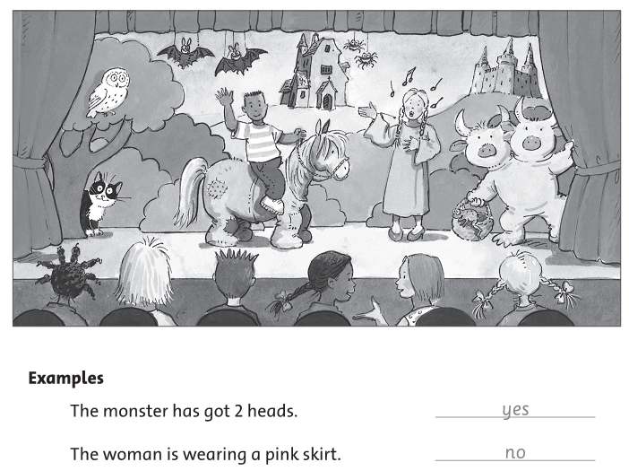

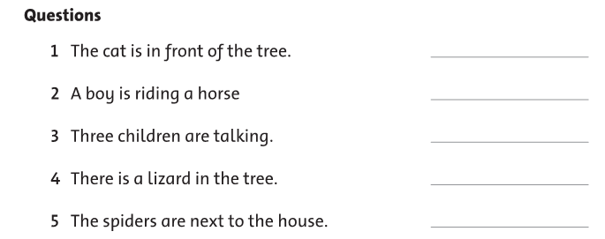

**7/ Look at the pictues. Look at the letters. Write the words. There is one example.**

