.

Name:................................................................class 1a.....

**TEST1**

1. **Fill in the blank. (Điền vào chỗ trống)**

|  |  |
| --- | --- |
| **0.**  b**o**y | **1.**  bo__k |
| cra___on  **2.** | **3.**  tea__her |
| **4.**  puppe__ | **5.**  gi___l |

**II. Complete the sentences. (Hoàn thành câu)**

|  |
| --- |
| welcome I’m are thank Hello book |

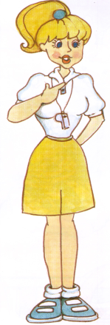 **Sue:** Hi! ............. Sue

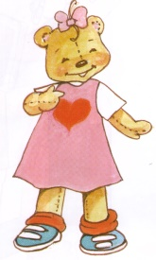 **Miss Dolly:** ………......, Sue.

**Sue:**  How .................. you?

**Miss Dolly:** Fine, ................. you.

**Sue:** A ...................

**Benny:** Thank you.

**Miss Dolly:** You’re ......................

**III. Match. ( Nối)**

1. Hi, I’m Benny. My name is Sue.

2. What’s your name? Hello, Benny.

3. How are you? You’re wellcome

4. Thank you. Fine, thank you.

I**V. Choose the right word to fill in the blank. ( chọn từ điền vào chỗ trống)**

1. I’m a ­­­_________________

A.a boy B. a teacher C. girl

2. My name’s ­­­­­­­­­­­_________________

A. Benny B. car C. a book

3. How_________you?

A. are B. you C. Sue

4. You’re________________

A. teacher B. welcome C. book

**V. Encircle the correct spelling. (khoanh tròn vào từ đúng)**

|  |  |
| --- | --- |
| **1.** book booh | **2.**    gurl girl |
| 3.  crayon croyan | **4.**  boy bouy |
| 5.  techer teacher | **6.**  Miss Bolly Miss Dolly |

**V. Unscramble the words: ( Sắp xếp các từ thành câu)** (2ms)

1. Benny / My/ ’s/ name /. → **My name’s Benny.**

2. morning, / Good / Sue/. → .……………………………………………………………….

3. you / are/ How/ ? → ….………………………………………………………….

4. you/thank/ Fine,. → …..………………………………………………………….

5. a / ’m / I / girl → …………………………………………………………….

6. a / I / boy / am / . → ………………………………………………………………

7. What / ’s / name/ your /?/ → ……………………………………………………………….

***The end.***

Name:................................................................class 1a.....

**TEST 2**

**I. Write the correct word. Choose from the box.** ( chọn từ trong khung viết vào tranh)

**boy teacher Benny book**

**Miss Dolly Sue girl crayon**

|  |  |  |  |
| --- | --- | --- | --- |
| 1.  **boy** | 2.  _________________ | 3.  _________________ | 4.  _________________ |
| 5.  _________________ | **book**6.  _________________ | 7.  _________________ | 8.  _________________ |

**II. Complete the dialogues**. ( hoàn thành bài hội thoại)

name

welcome

Fine

Hello

sorry

9.__________! My name’s Nga.

10. How are you? _______. Thank you.

11. Thank you. You’re_____________.

12. Ouch! I’m ____________.

13. What’s your name? My _______ is Benny.

**III. Match ( nối)**

|  |  |  |  |  |
| --- | --- | --- | --- | --- |
| 1. 1 quyển sách | ⚫ | ⚫ | 1. puppet | |
| 1. Cô giáo | ⚫ | ⚫ | 1. boy | |
| 1. Con rối | ⚫ | ⚫ | 1. Hello |
| 1. Bút sáp màu | ⚫ | ⚫ | 1. goodbye |
| 1. Bé trai | ⚫ | ⚫ | 1. a book |
| 1. Xin chào | ⚫ | ⚫ | 1. You’re welcome. |
| 1. Tạm biệt | ⚫ | ⚫ | 1. teacher |
| 1. Bé gái | ⚫ | ⚫ | h. crayon |
| 1. Cảm ơn | ⚫ | ⚫ | i. girl |
| 1. Không có chi | ⚫ | ⚫ | j. thank you. |

**IV. Unscramble (xếp lại cho đúng)**

1. you / are / How /?/ → ………………………..........

2. thank / Fine, / you/./ → ……………………….................

3. girl / ‘m / I / a/./ →………………………............................................................

4. your /What / is/ name /./ →………………………...........................................................

5. name / is / Son / My /./ →……………………….............................................................

6. Benny. / morning, / Good / →……………………….............................................................

V.  **Complete the words:**

|  |  |  |
| --- | --- | --- |
| **0 . Book** | 1. ___oy | 2. t___ac___er |
|  | 3. cra___on | 4. pup__et |

**VI. Matching. ( Nối)**

1. Hi, I’m Benny. My name is Sue.

2. What’s your name? Hello, Benny.

3. Thank you. See you tomorrow!

4. Good-bye! You’re welcome..

***The end.***

.

Name:................................................................class 1a.....

**TEST 3**

1. 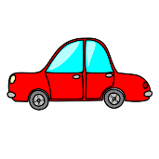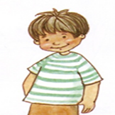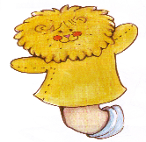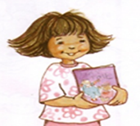**Connect and write. ( Nối và viết)**

c….r

1.

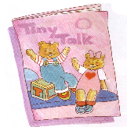

bo….k

2.

3.

b…y

4.

pu**p**pet

g…rl

5.

**II. Look at pictureand circle (nhìn hình và khoanh đáp án đúng)**

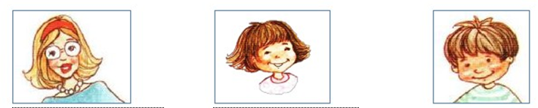

|  |  |  |
| --- | --- | --- |
| 1.  A. I’m a teacher..  B. I’m a girl.  C. I’m a boy. | 2.  A. I’m a girl.  B. I’m a boy.  C. I’m a teacher. | 3.  A. I’m a boy.  B. I’m a teacher.  C. I’m a girl. |

**III. Match (Nối)**

|  |  |  |  |
| --- | --- | --- | --- |
| 1. I’m a boy.  2. How are you?  3. I’m a girl.  4. Fine, thank you.  5. I’m a teacher. |  |  | a. Khỏe, cảm ơn.  b. Cô là giáo viên.  c. Mình là con trai.  d. Bạn có khỏe không?  e. Mình là con gái |

**IV. Put the words into the correct order (Sắp xếp các từ thành câu)**

1. you? / are / How/. **How are you?**

2. girl. / ’m /a/ I / . ...........................................................................................

3. a / boy ./ I / ’m/. .............................................................................................

4. I /’m / teacher / a /. ...............................................................................................

5. thank / Fine, / you/. ..............................................................................................

6. your / What / is / name /? ..............................................................................................

7. morning, / Good / teacher /. . ..............................................................................................

**V. Write** (Viết)

I’m a girl. I’m a teacher. I’m a boy.

My name’s Sue. My name’s Benny. Hello

|  |  |  |
| --- | --- | --- |
| ________________ | ___________________ | _____________________ |

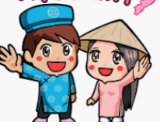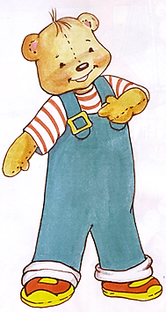

________________ ________________ ___________________

***VI. Choose and write: ( chọn từ và viết)***

***a book / a girl / Benny / a boy/ a crayon / a teacher / Sue /Miss Dolly / a puppet***

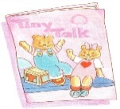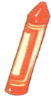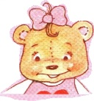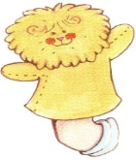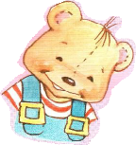

1.__________ 2. ________ 3.________ 4. __________ 5._________ __

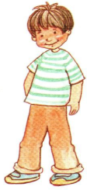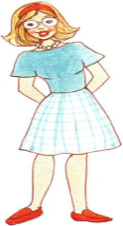

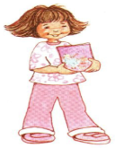

6.__________ 7. Miss Dolly 8.__________ 9. __________