Full name:...............................................................class 2a....

REVIEW

A. READING

I. Read and choose the correct response (đọc và chọn câu phản hồi đúng)

|  |  |
| --- | --- |
| *0. What’s your name?* | *-> A. I’m fine. B. My name’s Sue. C. I’m hot.* |
| 1.Hurry up! It’s raining. | -> A. I’m hot. B. I’m cold. C. I’m wet. |
| 2. It’s sunny. | -> A. I’m hot B. I’m wet. C. I’m cold. |
| 3. How are you? | -> A. I’m home. B. I’m fine. C. I’m five. |
| 4. I’m hungry. | -> A. Here it is. B. have some bread C. It’s good. |
| 5. How’s the weather? | -> A. It’s sunny. B. I’m hot C. She’s wet. |
| 6. Thank you. | -> A. Good night. B. You’re welcome. C. I’m ok. |
| 7. I like red. | -> A. Ok. B. I’m hot. C. Me, too! |
| 8. That’s my bear. | -> A. No, it’s my bear. B. Here it is. C. I’m home. |

II. Odd one out (tìm từ khác loại)

0. A. cookie B. apple C. pudding D. boy

1. A. raining B. cold C. hot D. wet

2. A. doctor B. wet C. farmer D. teacher

3. A. blue B. color C black D. green

4. A. chicken B. noodles C. soup D. juice

5. A. sister B. mommy C. daddy D. farmer

6. A. one B. five C. fine D. six

7. A. crayon B. bear C. pen D. book

8. A. clean up B. stand up C. line up D. wet

my Be

up a

It’s Green I’m Red Stop an

III. Complete the dialogue with the words in the box:

|  |  |
| --- | --- |
| 0. Hurry up! It’s rainy.  I’m wet. | |
| 1. Red light. __________!  ___________light. Go!  She’s __________ police officer. | 2. That’s _________ blanket.  No! _________ my blanket.  Shh! _________ quiet! |

IV. Fill in the blank (Điền từ vào chỗ trống)

snowing noodles sunny stop good ~~weather~~ my

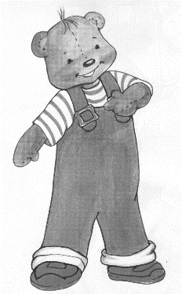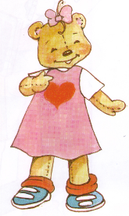 Sue: How’s the *weather*?

Benny: It’s …………………(5)

I’m hot and hungry.

Sue: Have some ………………(6)

Benny: Mmm. It’s …………..(7)

Sue: That’s ……….(8) candy.

Benny: No! It’s my candy.

V. Read and circle (Đọc và khoanh tròn vào câu đúng)

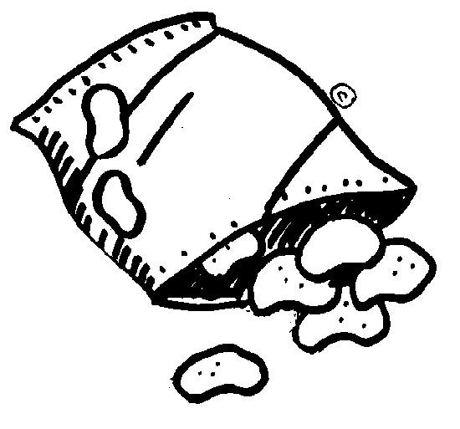

1. 2.

A. chips A. He’s a farmer.

B. apples B. He’s a doctor.

C. pudding C. She’s a police officer.

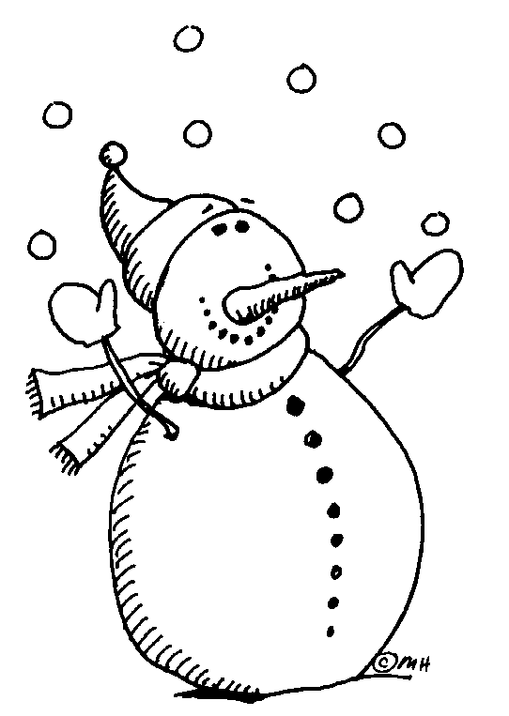3. 4.

A. Have some noodles. A. snowing

B. Have some soup. B. raining

C. Have some chicken. C. sunny

VI. Read and match. (Đọc và nối)

*0. It’s raining.* ● ● a. Go!

1. I’m hungry. ● ● b. See you tomorrow.

2. Green light. ● ● c. No! it’s my puppet.

3. Goodbye. ● ● *d. I’m wet.*

4. That’s my puppet. ● ● e. Have some cookies.

5. How are you? ● ● f. No. Not today.

6. I want chips. ● ● g. I’m ok. Thanks.

● h. Stop!

*0. d* 1.___ 2.___ 3.___ 4.___ 5.___ 6.___

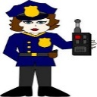VII. Match. (2 points) (Nối)

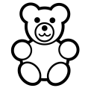0. Red light. Stop! • •

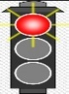13. That’s my bear. • •

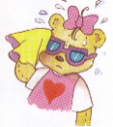14. She’s a police officer. • •

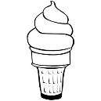15. I want ice cream. • •

16. I’m hot. • •

## Khoanh tròn đáp án đúng:

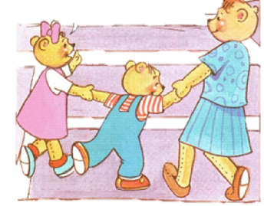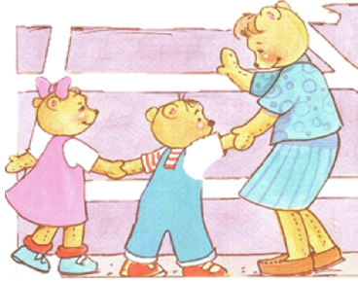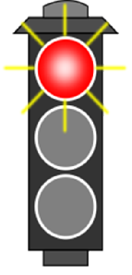

1. A. go

1. stop
2. go slow

2. A. go

1. stop
2. go slow
3. A. green light
4. red light
5. yellow light

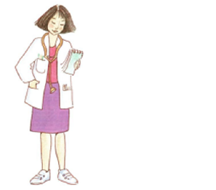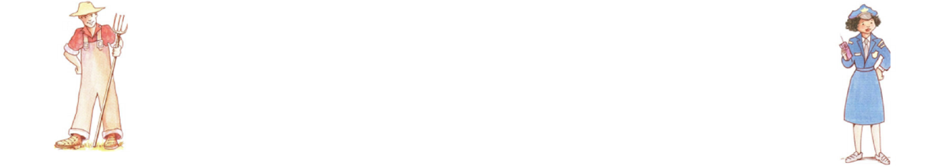

1. A. doctor
2. farmer
3. police officer
4. A. doctor
5. farmer
6. police officer
7. A. farmer
8. doctor
9. police officer

IX. Look at the picture and choose the correct word. (Chọn từ đúng cho hình)

|  |
| --- |
| Description: Kết quả hình ảnh cho sunny clipart black and white  *0. suny sunny sunni* |
| 1. fire five fine 1082424-Clipart-Three-Eyed-Number-Five-Character-Royalty-Free-Vector-Illustration |
| Description: Kết quả hình ảnh cho pillow clipart black and white  2. pullow pillow pilow |
| 3. taecher teacher titcher tải xuống (3) |
| Description: https://puu.sh/vLmkL/d3303af620.jpg  4. puuding pudding puding |
| 5. *snauwing snowing* snawing Hình ảnh có liên quan |
| 6. apples aples apple images (3) |

1. WRITING.
2. Write the words

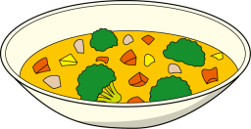

0. raining 2. ___________ 3. __________

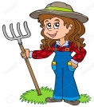

4. __________ 5. __________



6. ______________ 7. ___________

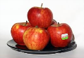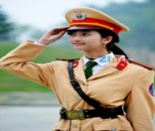

8. _________________ 9. ______________

II. Reorder the words to make correct sentence. (Sắp xếp chữ thành câu đúng)

|  |
| --- |
| *0. Go / light. / Green / ! -> Green light. Go!* |
| 1. Have / ice cream / some / . -> _______________________________________ |
| 2. officer / a / I’m / police. -> _______________________________________ |
| 3. not / I’m / hot / . -> _______________________________________ |
| 4. book / It’s / yellow / my / . -> _______________________________________ |
| 5. want / I / chips /. -> _______________________________________ |
| 6. a / farmer / He /’s / . -> _______________________________________ |
| 7. name / is / Sue / My /. -> _______________________________________ |
| 8. thank / Fine, / you / . -> _______________________________________ |
| 1. hungry /’m / I /. -> _______________________________________ |
| 1. stop / red / ! / light / . -> _______________________________________ |

III. Write the response :

1. What is your name? -> _________________________________________

2. How are you? -> _________________________________________

3. How old are you? -> __________________________________________

4. How’s the wether? -> _________________________________________

IV. Complete the sentences.( hoàn thành các câu)



|  |  |  |
| --- | --- | --- |
| 1. It’s _______________  I’m ________________ | 2. It’s _______________  I’m ________________ | 3. It’s _______________  I’m ________________ |
| 4.  It_____________ | 5.  Have_________________ | 6.  That_________________ |
| 7. Kết quả hình ảnh cho hinh anh giao vien  she_____________________ | 8. Bác sĩ là gì?  He_____________________ | 9. Kết quả hình ảnh cho cảnh sát  He___________________ |

V. Fill in the missing letters. (Điền từ vào chỗ trống)

|  |  |  |  |
| --- | --- | --- | --- |
| do__to___ | Fa___m___r | S__op | p__li__e of__icer |
| sw__n_____ | _____li__e | r________ | nood______ |