UNIT 1: They’re from Australia!
Exercise 1: Look and circle.
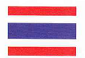  I’m from Thailand/ Japan. | He’s from Australia/Vietnam.
They’re from Mexico/the U.S.A | She’s from Brazil/ Vietnam.
We’re from Korea/ Mexico. | I’m from Vietnam/ the U.S.A.
He’s from Brazil/ Mexico. | They’re from Thailand/ Mexico.

UNIT 2: My weekend
Exercise 1: Look and circle.
fish/ read comics | 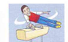  do gymnastics/ fish | 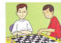  play chess/ take photos
play basketball/ fish | 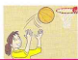  play volleyball/  play basketball | take photos/  read comics
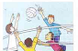  play volley ball/  play chess | 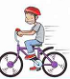  do gymnastics/ ride a bike | 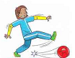  play football/  play basketball

Exercise 2: Write
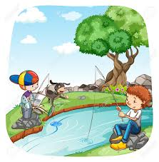  They……fish……near the river. | 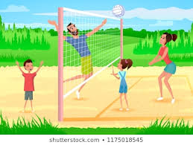  ……………………every afternoon.
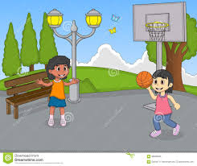  ……………………..in the park. | 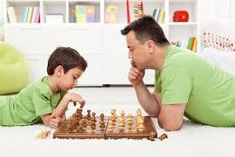  ………………..in the evening.

UNIT 3: MY THINGS
Exercise 1: Look and write
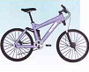 | 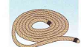 | 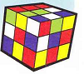 | 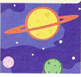
……bike……….. | …………………. | …………………. | ………………….
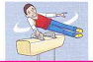 |  | 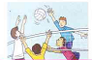 | 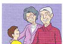
…………….. | …………………. | …………………. | ………………….
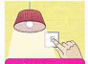 |  | 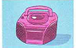
…………….. | …………………. | …………………. | ………………….
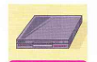 | 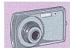 | 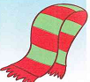 | 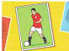
…………….. | …………………. | …………………. | ………………….
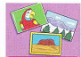 | 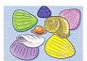
…………….. | …………………. | …………………. | ………………….
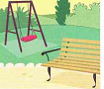 | 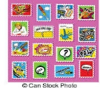
…………….. | …………………. | …………………. | ………………….
UNIT 4: WE’RE HAVING FUN AT THE BEACH!
Exercise 1: Look and write
 | 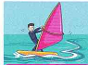 | 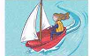
……rope…….. | …………………. | …………………. | ………………….
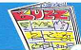 |  | 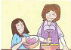 | 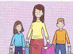
…………….. | …………………. | …………………. | ………………….
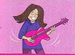 |  |  | 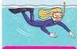
…………….. | …………………. | …………………. | ………………….
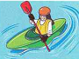 |  | 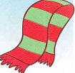
…………….. | …………………. | …………………. | ………………….
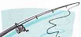 | 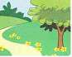 |  | 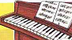
…………….. | …………………. | …………………. | ………………….
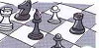 | 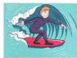
…………….. | …………………. | …………………. | ………………….
UNIT 5: A FUNNY MONKEY!
Exercise 1: Look and write
 | 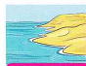 | 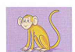 | 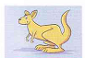
……rope…….. | …………………. | …………………. | ………………….
 | 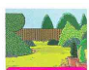 | 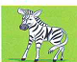 | 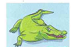
…………….. | …………………. | …………………. | ………………….
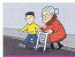 | 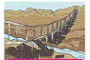 | 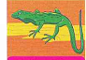 | 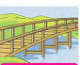
…………….. | …………………. | …………………. | ………………….
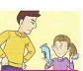
…………….. | …………………. | …………………. | ………………….
 | 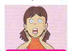 | 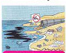 | 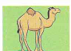
…………….. | …………………. | …………………. | ………………….
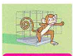 |  | 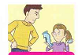
…………….. | …………………. | …………………. | ………………….
UNIT 6: JIM’S DAY
Exercise 1: Look and write
 | 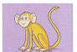 | 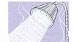 | 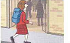
……rope…….. | …………………. | …………………. | ………………….
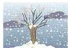 |  |  | 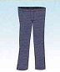
…………….. | …………………. | …………………. | ………………….
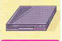 | 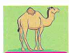 | 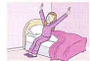 | 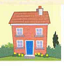
…………….. | …………………. | …………………. | ………………….
 |  |  | 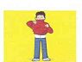
…………….. | …………………. | …………………. | ………………….
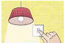 |  |  | 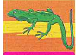
…………….. | …………………. | …………………. | ………………….
 |  | 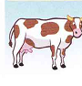 | 
      

