PHU THO 1 primary school  Class: 1/  Name:…………………………. | Date:  Test  Duration: 35 minutes

MINI TEST

I/ Read and check: (2ms)

  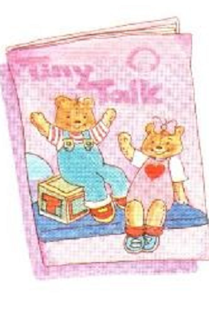  down | 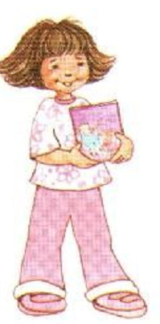    girl
book | Benny

II/ match:(2ms)

 |  | _____________________
 |  | ______________________
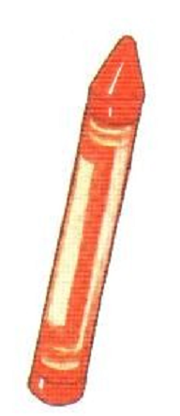

III/ Reorder the words to make correct sentences:(4ms)

1/ name’s / My / Benny |  | _______________________
2/ you/ How / are /?/ |  | _______________________
3/ teacher / I’m / a / |  | _______________________
4/ Good, / Benny / morning |  | _______________________

