REVIEW 2 – GRADE 5

# Question 1- Read and write the numbers. There is one example.

Example: You write:

# 0-They are taking photos.

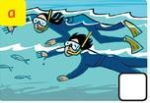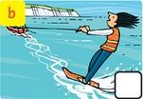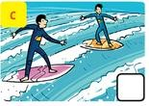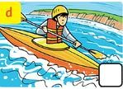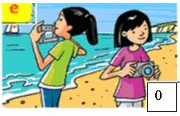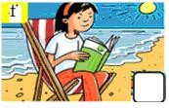

1. **They are taking photos.** 3- He is kayaking.
2. They are surfing. 4- They are snorkeling.
3. She is reading a book. 5- She is waterskiing.

# Question 2- Read and check (√ ) the box. (1,25pt) There is one example.

Example: 0-You write: 

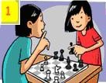 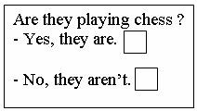

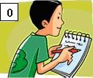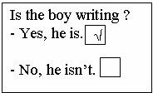

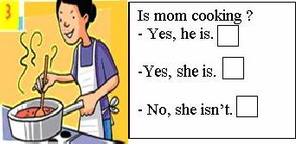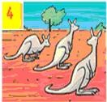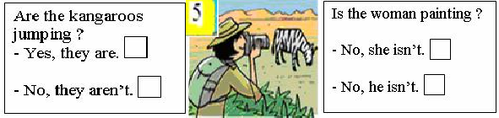

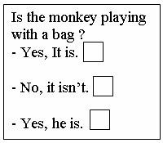

**Question 3- Write the correct form in the present simple. ( 1pt) 0-** They ( have) breakfast with their family.

# - They have breakfast with their family.

1. Ly and Vy ( not catch ) the bus to school.

………………………………………………………………………………………… 2- The boy ……………( have) breakfast at seven thirty.

………………………………………………………………………………………… 3- The boy…………….( not have ) a shower at eight fifteen.

………………………………………………………………………………………… 4- The boy …………..( catch ) the bus at eight forty-five ?

…………………………………………………………………………………………

# Questions 4: Read the text, circle the false word and correct.

My name is Ruby. In the morning, I get up at seven o’clock. I get dressed. I have breakfast, breads, eggs and milk, at seven. Then I go to school at eight o’clock. I go to school by bus. I take my coat and my school bag. Our bus is blue. My mum is a doctor. She starts work at six o’clock, so I don’t see her in the morning.

*Answer the question:*

* 1. What’s her name?

...............................................................................................................................................

* 1. What time does Ruby get up?

...............................................................................................................................................

* 1. What does she eat for breakfast?

...............................................................................................................................................

* 1. Does she go to school at seven o’clock?

...............................................................................................................................................

* 1. How does she travel to school?

...............................................................................................................................................

* 1. Does she take her coat and her school bag?

...............................................................................................................................................

* 1. What color is her bus?

...............................................................................................................................................

* 1. What does her mother do?

...............................................................................................................................................

* 1. Does she see her mother in the morning?

...............................................................................................................................................

* 1. What time does her mother start work?

...............................................................................................................................................

*Find and correct the mistakes.*

|  |  |
| --- | --- |
| 1. Ruby gets up at eight o’clock. | **seven** |
| 2. She goes to school in the afternoon. |  |
| 3. She goes to school by bike. |  |
| 4. Her school bus is yellow. |  |
| 5. Ruby takes her hat and her school bag. |  |
| 6. Ruby’s mum is a teacher. |  |

# Question 5: Write the answers ( - Yes, ... .  No, )

Ex: Are you ten? **** - *Yes, I am.*

* + 1. Is she sad? **** -
    2. Can he play football? **** -
    3. Do you like carrot? **** -
    4. Are they happy? **** -
    5. Are you and Lan students? **** -
    6. Do you like playing volleyball? **** -
    7. Does Lan like swimming? **** -
    8. Can I turn on the light? **** -
    9. Is she doing her homework? **** -
    10. Are you and Lan students? **** -
    11. Can you put on your coat, please? **** -
    12. Are Wosy and Max sailing? **** -