BÀI ÔN TẬP – MÔN TIẾNG ANH – LỚP 5
I. Write:
1/ The turtle is _______ ( slow ) than the rabbit.
2/ The motorcycle is ______ ( fast ) than the bicycle.
3/ The giraffe is ________ ( tall ) than the zebra.
4/ Hens are _________ ( small ) than dogs.
5/ Elephants are __________ ( big ) than monkeys.
II. Write was or were:
Yesterday Nam and Hoa ________ at the beach with their friends. It ________ sunny. The children _________ very happy. At twelve thirty, they _________ hungry and thirsty. Nam _______ hot. Hoa ________ tired.
III. Write:
days, January , December, November, February, March, October,
weeks, September, April, May, August, July, June , months

Twelve months in a year
January, February, __________, and April,
January, ____________, March, and April,
___________, February, March, and April,
Twelve _________ in a year!
May, June, July, then __________, and September,
May, June, ________, then August, and September,
May, June, July, then August, and _____________,
Twelve _________ in a year!
October, __________, and December,
_________, November, and December,
October, November, and ___________,
Twelve _________ in a year!
IV. Write:
21: twenty – one

32: ___________

43: ___________

54: ___________

65: ___________

76: ___________

87: ___________

98: ___________

100: ___________

Ten + twenty =

Thirteen + eleven =

Forty + fifty- one =

Seventy-two + twenty-eight =

Ninety-six – sixty- two =

V. Write:

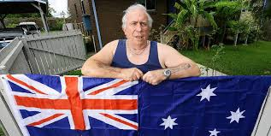

1/ Where is he from ? _________________

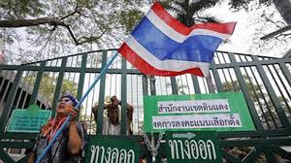

2/ Where is she from ? _________________


3/ Where are they from ? _________________

4/ Where is she from ? _________________
VI. Write:
0. They like playing chess. 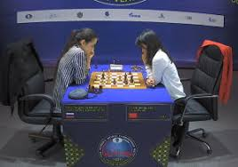
1. ___________________________ 
2. ___________________________ 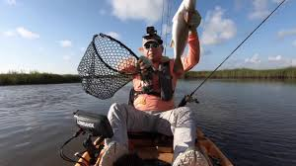

3. ___________________________ 

4. ___________________________ 
VII. Answer the questions:
1/ Can I use your MP3 player ?
____________________________

2/ Can you play volleyball ?
____________________________

3/ Do you have two cousins ?
____________________________

4/ Are you from Brazil ?
____________________________
5/ How many notebooks do you have ?
____________________________

6/ What’s your favorite season ?
____________________________

7/ Do you like doing gymnastics ?
____________________________

8/ Can you help me with my homework, please ?
____________________________

9/ What time do you have breakfast ?
____________________________
10/ What do you like doing at the beach ?
__________________________
VIII. Unscramble the letters:
1. furs:
2. uidwnrsf:
3. iasl:
4. ceabh:
5. tawieskr:
IX. Fill in the blanks with “am”, “is” or “ are”:
1. Kate ______ swimming now.
2. Mom _______ surfing at the moment.
3. I _______ not playing the guitar.
4. The boys _______ not watching TV.
5. They _______ visiting their family.
6. My mother ______ cooking dinner.
7. The girls ______ not shopping.
8. We _____ using a computer.
9. The children ______ kayaking.
10. They ______ waterskiing now.
X. Write the verb. Then answer the question for you.( Yes, I do. / No, I don’t.):
1. Do you like _________ ( go) on holiday? _________________________
2. Do you like ___________ ( fly) kites? _________________________
3. Do you like ____________ ( visit) zoos? _________________________
4. Do you like ___________( play) computer games?________________________
5. Do you like __________ (read)? ________________________
XI. Leave one word:
1. moankey:
2. zeibra:
3. penguint:
4. lizoard:
5. crofcodile:
XII. Say thew words. Circle the word that doesn’t have oy or oi:
1. boy toy coin stone
2. oil coin coat soild
3. gate boy oyster oil
4. boy blue soil toy
5. robot soil toy boy
XIII. Read and write the animal name:
1. It’s small, black and yellow and it can fly. It sounds like “me”. _____________
2. It lives in the sea. I’m frightened of it. It sounds like “ park”. ______________
3. It eats grass. It sounds like “now”. ____________
4. It has no legs and no arms. It is long. It makes the noise “ sssssss”. ___________
5. It’s green and jumps very well. It sounds like “dog”. _____________
XIV. Look and write
get dressed comb my hair have a shower have breakfast
get up go to school catch the bus brush my teeth

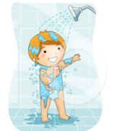 |  |  | 
 |  | 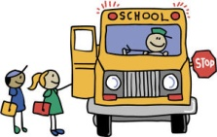 | 
 | .

XV. Read and circle the corrct words.
- He gets/ get up early. | - We catch/catches the bus. | - Tony have/has breakfast with his family.
- Lisa brushes/brush her teeth every morning. | - I have /has shower every day. | - Do/does you go to school everyday ?
- She have /has breakfast every morning. | - Do/Does they catch the bus every morning? | - They go /goes to school everyday.
- Anna don’t/doesn’t catch the bus. | - What time do/does Toby go to school? | - Do/Does they brush their teeth at night?
- He don’t/doesn’t walk to school. | - My sister get/gets up at six o’clock. | - Do/Does she have a shower at night?

XVI.Look at the table.Are the sentences true or false? Write T or F , then write sentences.
 | Ben | Lily | Toby | Anna
get up early | ✓ | ✗ | ✗ | ✓
go to school by car | ✗ | ✗ | ✓ | ✓
play tennis | ✓ | ✓ | ✗ | ✗
get dressed at 8 o’clock | ✗ | ✓ | ✗ | ✗

- Ben gets up early. | T | He gets up early.
- Lily goes to school by car.
- Toby doesn’t play tennis.
- Anna gets dressed at 8 o’clock.
- Ben goes to school by car.
- Lily plays tennis.
- Toby gets up early.
- Anna goes to school by car.

XVII.Complete the sentences.

Sunday is Lily’s favorite day. She usually gets up ( get up) at ten o’clock , then she ___________( have ) a big breakfast with her family.
After that, she always _______ ( go ) for a long walk in the park. She usually ___________( meet) her friends and they sometimes ________(play) tennis
In the afternoon, Lily ________ (watch ) TV or __________ (listen ) to music. Then, In the evening she always ___________(visit ) her grandparents and they usually ________(have) dinner together.
Lily always look forward to Sundays!

