NAME: --------------------------------------------
CLASS:2

Chicken noodles pillow blanket bear wet candy chips ice cream hot soup cold
1.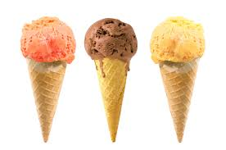2.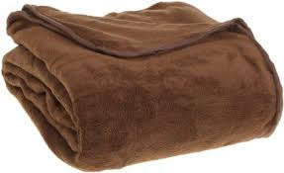3. 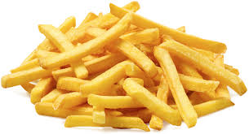
…………………… ……………………….. ……………………….
4 . 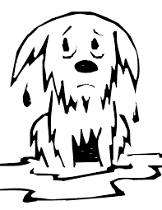5.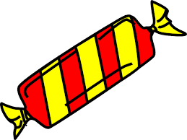6. 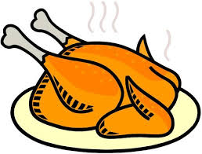
…………………… ……………………………. ……………………………
7. 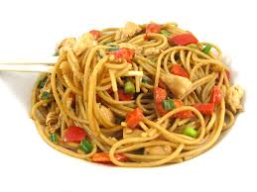 8. 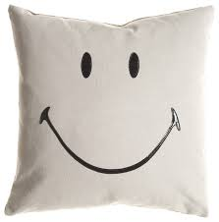 9.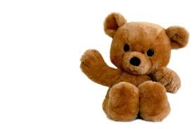………………………… …………………………..
II Write
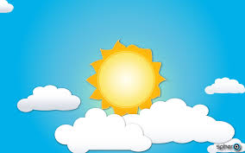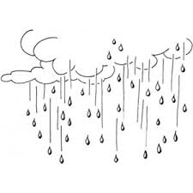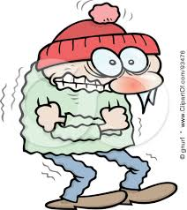
It’…. Sno….ing
I...’s sunny
It’s rai….ing
…….. wet
I’m col….
…… Ho…

III. UNCRAMBLE
- Hungry / ’m / I
  - …………………………………………………………………………………………
- Chicken / some / have
  - …………………………………………………………………………………………
- Some / noodle / have
  - …………………………………………………………………………………………
- Have / soup / some
  - …………………………………………………………………………………………
- Candy / want / I
  - ………………………………………………………………………………………..

- is / a / police / she / officer
  - ………………………………………………………………………………………..
- My / pillow / that / ’s
  - …………………………………………………………………………………………
IV: WRITE


  

