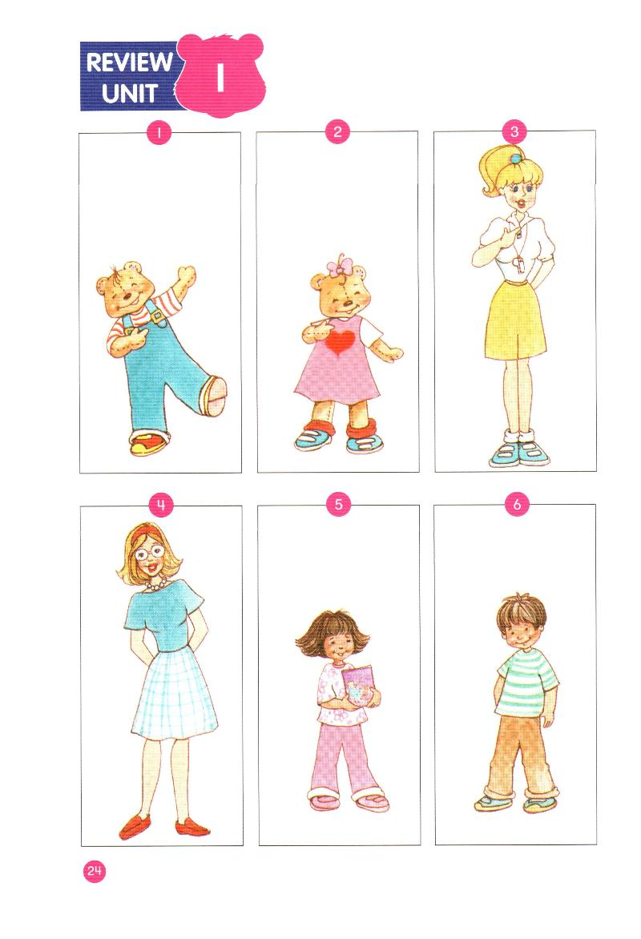

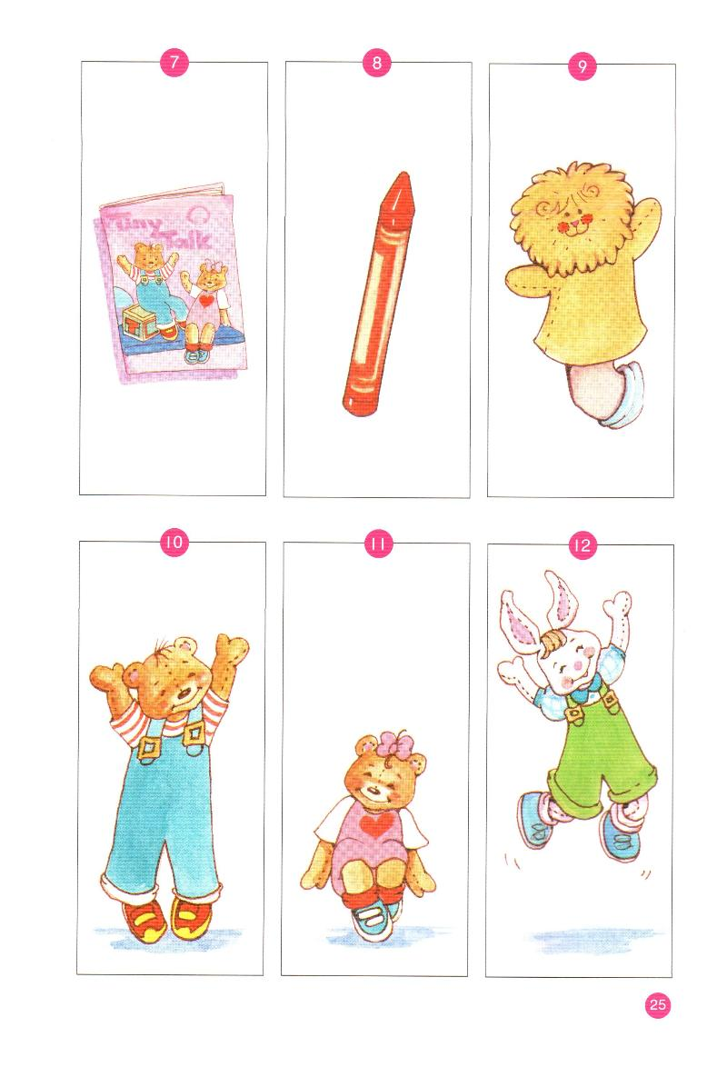
I/Điền các từ cho sẵn vào ô trống:
Benny , thank you morning,you,welcome
Sue book name teacher
1/ Benny: Hi, I am Benny.
2/ Sue: Hello, I am ____________ .
3/ Sue: My ____________ is Sue.
4/ Miss Dolly: Good ____________, Sue.
5/ Miss Dolly: How are you?
6/ Benny and Sue: Fine, ___________ .
7/ Sue: A _______________
8/ Benny: Thank………………. .
9/ Miss Dolly: You’re ………………...
10/ I’m a ………………………..

III/ Reorder the words to make correct sentences:
1/ name’s / My / Benny ………………………………………………….
2/ you/ How / are /?/ ……………………………………………………..
3/ teacher / I’m / a / ……………………………………………………..
4/ Good, / Benny / morning ………………………………………………
5. thank / Fine / you ? ……………………………………………………….
6/ Miss/ I / Dolly /am. ……………………………………………………
7/ re / welcome / you’ ………………………………………………………

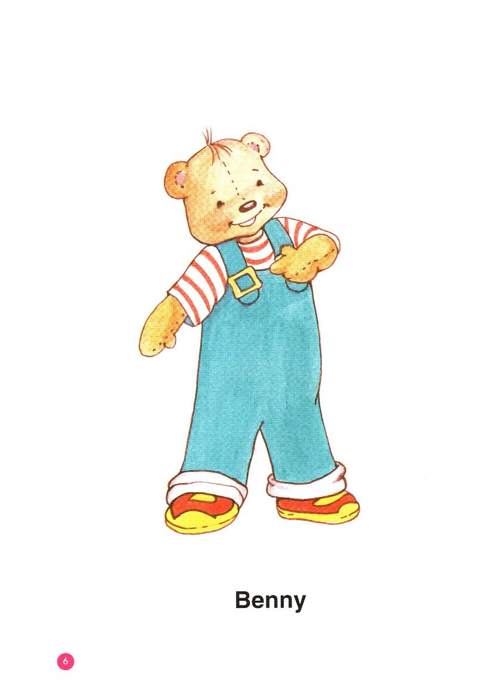
1/__________ 2/ ________________ 3/ ______________

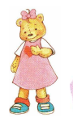

4/ _______________ 5/ _________________ 6/________________

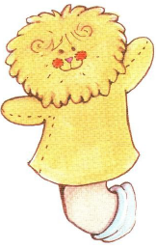

7/ …………………. 8/…………………….. 9/…………………………

