Exercise
I.Match:

- Benny • • 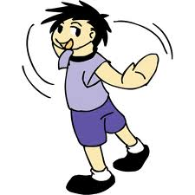

- Stand up • • 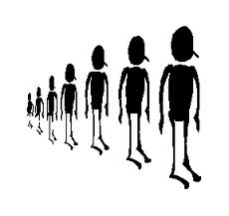

- Line up • • 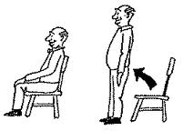

- Turn around • • 

- sit down • • 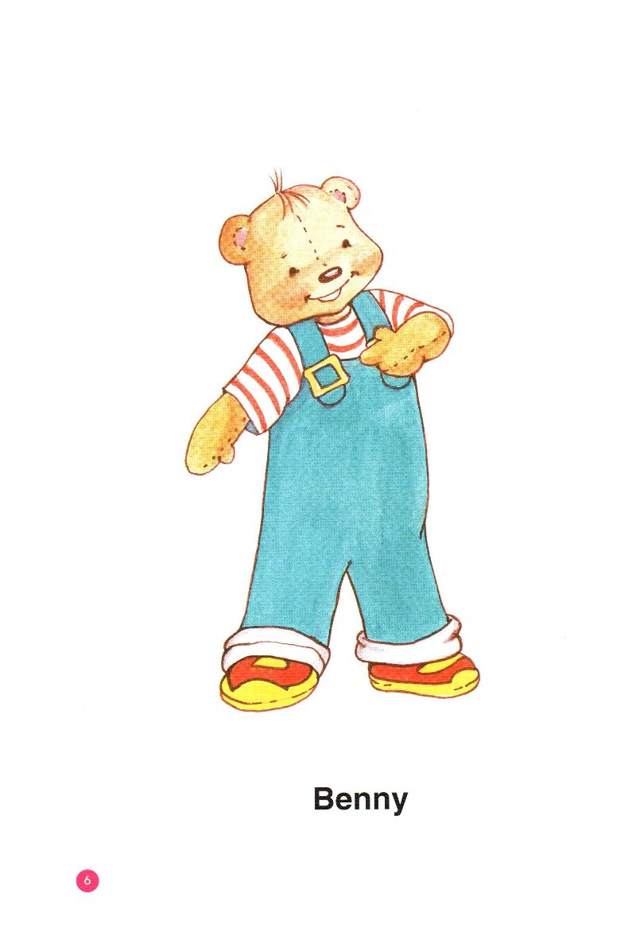
- jump • •

II.Circle

- It’s a car. 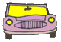 

- It’s a crayon.  

- It’s a bus. 

- It’s a puppet. 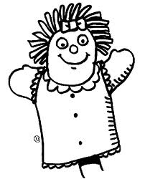 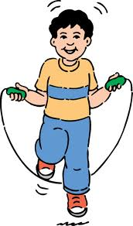

III.Match

A | B
- Cookies, please | a. Fine, thank you.
- Thank you. | b. I’m sorry.
- How are you? | c. Here you are.
- Ouch! | d. You’re welcome

IV . Complete the conversations .

Benny see name’s please too I’m fine

Bye like Good Here you thank you’re

Ex : I’m Benny .
Hello , Benny .

1 . My …………Sue . 4 . Good …………..!
………… morning , Sue . …………you tomorrow .

2 . How are ………….? 5 . Cookie ,…………..
…………, thank you . …………you are .

3 . A book , ………..you .
…………welcome .

V. Look and write .

Line up sit down jump apples stand up

a boy cookies Benny puppet truck

1 ………………………… 2…………………………

3………………………… 4……………………………

5…………………………….. 6…………………………..

