PhuTho Primary School.
Class:1/……….
Name:…………………………………….…………………….

Marks Teacher ‘s remarks

I .Write .(3ms)

teacher Sue girl Miss Dolly boy Benny

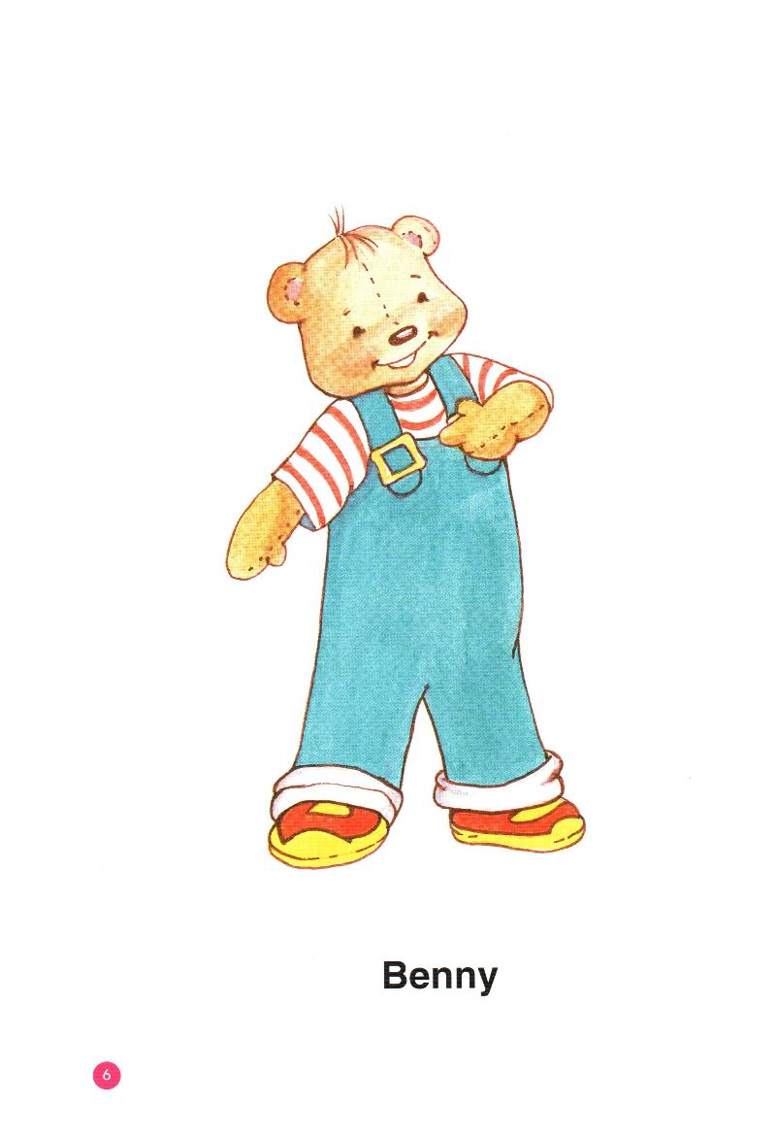
1/__________ 2/ ________________ 3/ ______________

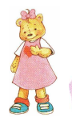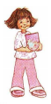

4/ _______________ 5/ _________________ 6/________________

II/ Reorder the words to make correct sentences:(4ms)

1/ name’s / My / Benny: ______________________________________________

2/ you/ How / are /?/ _______________________________________________

3/ teacher / I’m / a / _________________________________________________

4/ Good / Miss Dolly / morning ________________________________________

III/ Complete the conversations (3ms)

Benny , thank you , morning, you, welcome , Sue ,book , name , teacher

1/ Benny: Hi, I am Benny.

3/ Sue: My ____________ is Sue.

4/ Miss Dolly: Good ____________, Sue.
5/ Miss Dolly: How are you?

6/ Benny and Sue: Fine, ___________ .

7/ Sue: A _______________

8/ Benny: Thank__________________

9/ Miss Dolly: You’re _____________________

